DSA0601 • DATA HANDLING AND VISUALIZATION

LAB EXPERIMENT RECORD

SET 19 – SURVEY RESPONSES ANALYSIS

Department | AIDS
Course Code / Course Name | DSA0601 / Data Handling and Visualization
Experiment | Data Visualization using R
Name | M V Raghavan
Register Number | 192424373
Date | 13 October 2026
Day | Tuesday

Aim
To analyze survey response data using a grouped bar chart, stacked bar chart, data table, and an interactive dashboard workflow.

Dataset

Survey ID | Question 1 | Question 2 | Question 3
1 | A | B | C
2 | B | A | D
3 | C | A | B
Note: The analysis uses exactly the three survey records supplied for SET-19.

PROGRAM 1: Grouped Bar Chart – Question 1
To create a grouped bar chart to visualize the distribution of answers for Question 1 and label the chart elements.
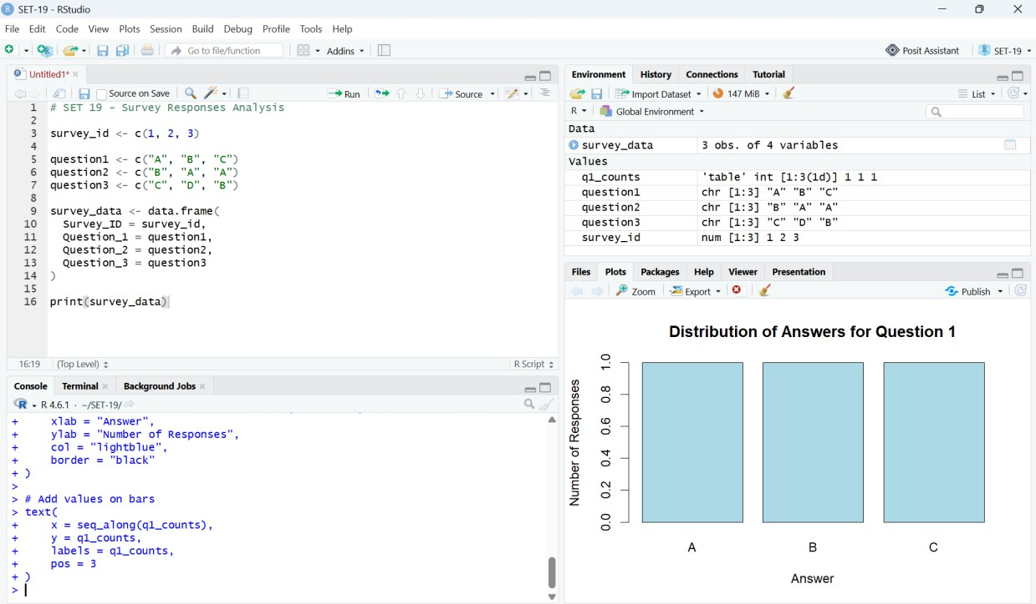
# SET 19 - PROGRAM 1
survey_id <- c(1, 2, 3) question1 <- c("A", "B", "C")
question2 <- c("B", "A", "A")
question3 <- c("C", "D", "B")

survey_data <- data.frame( Survey_ID = survey_id, Question_1 = question1, Question_2 = question2, Question_3 = question3
)
q1_counts <- table(survey_data$Question_1) barplot(
q1_counts,
main = "Distribution of Answers for Question 1", xlab = "Answer",
ylab = "Number of Responses", col = "lightblue",
border = "black"
)

text(seq_along(q1_counts), q1_counts, labels = q1_counts, pos = 3)

Output 1: Distribution of Answers for Question 1 – RStudio Execution Screenshot

Observation
Question 1 contains one response each for A, B, and C. Therefore, all three bars have equal height.

PROGRAM 2: Stacked Bar Chart – Overall Responses
To generate a stacked bar chart representing the overall distribution of responses for all three questions.
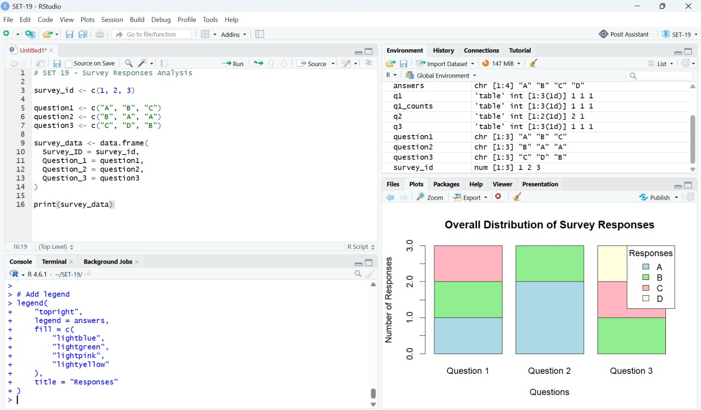
# SET 19 - PROGRAM 2

q1 <- table(survey_data$Question_1) q2 <- table(survey_data$Question_2) q3 <- table(survey_data$Question_3)

answers <- sort(unique(c(names(q1), names(q2), names(q3))))

response_matrix <- matrix(0, nrow = length(answers), ncol = 3) rownames(response_matrix) <- answers colnames(response_matrix) <- c(
"Question 1", "Question 2", "Question 3"
)

response_matrix[names(q1), "Question 1"] <- q1 response_matrix[names(q2), "Question 2"] <- q2 response_matrix[names(q3), "Question 3"] <- q3
print(response_matrix) barplot(
response_matrix,
beside = FALSE,
main = "Overall Distribution of Survey Responses", xlab = "Questions",
ylab = "Number of Responses",
col = c("lightblue", "lightgreen", "lightpink", "lightyellow"), border = "black"
)

legend(
"topright", legend = answers,
fill = c("lightblue","lightgreen","lightpink","lightyellow"), title = "Responses"
)

Output 2: Overall Distribution of Survey Responses – RStudio Execution Screenshot

Observation
The stacked chart compares response composition across the three questions. Question 2 contains A twice and B once, while Questions 1 and 3 contain three different responses each.

PROGRAM 3: Survey Response Data Table
To build a table showing the survey response data for each survey and label the table elements.
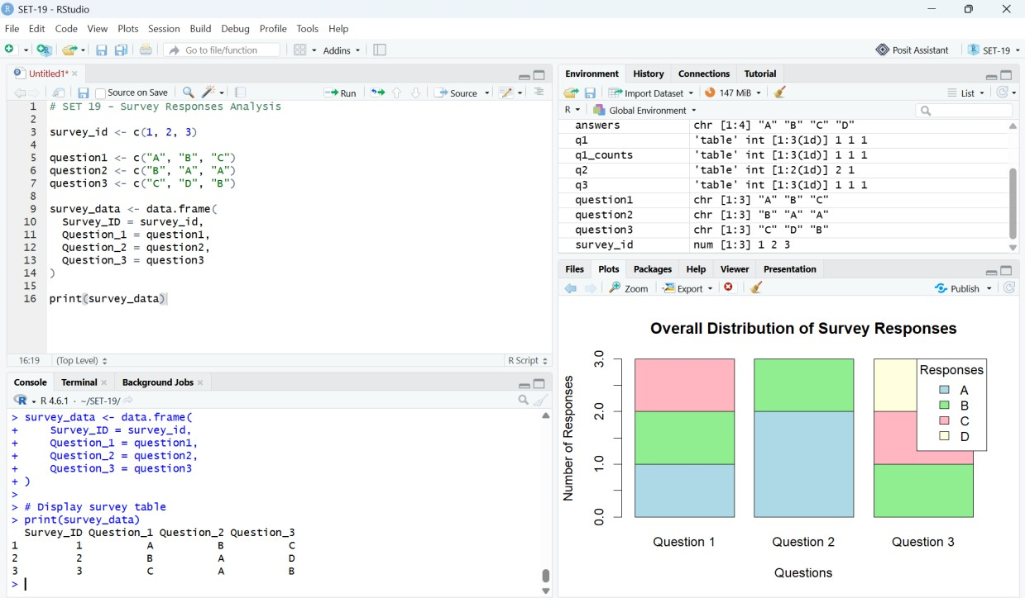
# SET 19 - PROGRAM 3

survey_id <- c(1, 2, 3) question1 <- c("A", "B", "C")
question2 <- c("B", "A", "A")
question3 <- c("C", "D", "B")

survey_data <- data.frame( Survey_ID = survey_id, Question_1 = question1, Question_2 = question2, Question_3 = question3
)

print(survey_data)

Output 3: Survey Response Data Table – RStudio Console Screenshot

Observation
The table displays Survey ID and the responses to all three questions for each survey record.

PROGRAM 4: Interactive Tableau Dashboard
To develop a Tableau dashboard combining the grouped bar chart, stacked bar chart, and table for interactive exploration.

Tableau Sheet 1 – Grouped Bar Chart
- Columns → Question 1
- Rows → Number of Records
- Use Question 1 as a category/color if required
- Title: Distribution of Answers – Question 1

Tableau Sheet 2 – Stacked Bar Chart
- Create a Question field containing Question 1, Question 2, and Question 3.
- Columns → Question
- Rows → Number of Records
- Color → Answer
- Enable stacked bars
- Title: Overall Distribution of Survey Responses

Tableau Sheet 3 – Data Table
- Display Survey ID, Question 1, Question 2, and Question 3.
- Format the worksheet as a text table.
- Title: Survey Response Data

Dashboard Layout

Dashboard Note
┌──────────────────────────┬──────────────────────────┐
│ Question 1 Bar Chart │ Stacked Bar Chart │
├──────────────────────────┴──────────────────────────┤
│ Survey Response Data Table │
└──────────────────────────────────────────────────────┘

The supplied execution evidence contains the three RStudio outputs. No executed Tableau screenshot was supplied, so this section records the required Tableau construction steps without claiming a Tableau execution result.

Procedure
- Create vectors for Survey ID and the three survey questions.
- Combine the vectors using data.frame() to create the survey dataset.
- Use table() to calculate Question 1 response frequencies.
- Create the grouped bar chart using barplot() and add values using text().
- Create frequency tables for all three questions and combine them into a response matrix.
- Generate the stacked bar chart and add a legend.
- Display the complete survey dataset using print().
- Create the corresponding Tableau worksheets and combine them into a dashboard.

Overall Insights
- Question 1 has A, B, and C once each.
- Question 2 has A twice and B once.
- Question 3 has B, C, and D once each.
- Answer A has the highest overall frequency in the supplied dataset.
- The stacked bar chart provides a compact comparison of response composition across questions.
- The data table provides exact values for every survey record.

Result
The survey response dataset was successfully analyzed in RStudio using a grouped bar chart, stacked bar chart, and data table. The required Tableau dashboard structure was also specified for interactive exploration of the survey responses.

Submission Note
For final submission, the three supplied RStudio screenshots are included as execution evidence. If your faculty requires proof of Tableau execution, capture the completed Tableau dashboard and insert that screenshot in the Program 4 section.

